

CIS C290

M04 Lab Assignment: Regression Analysis

Activity 1 Part 1. Load the winequality.csv file into the Python environment and include a screenshot of the output.
#Load the data from winequality.csv
import pandas as pd

# Load the data from the specified CSV file into a pandas DataFrame
df = pd.read_csv('/content/winequality.csv')

# Display the first few rows of the DataFrame to confirm the data is loaded
print(df.head())

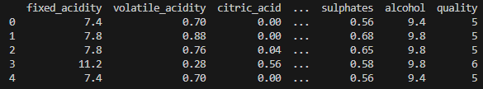

Activity 1 Part 2. Run a simple linear regression to determine to predict quality based on pH level.
# Simple linear regression with a target variable as 'quality' and ‘pH’ as the predictor variable and a summary of the regression output, a chart, and an interpretation of the results

import pandas as pd
import statsmodels.api as sm
import matplotlib.pyplot as plt

# df = pd.read_csv('/content/winequality.csv')

# Define the predictor and target variables
X = df['pH']
y = df['quality']

# Add a constant to the predictor variable (intercept term)
X = sm.add_constant(X)

# Fit the linear regression model
model = sm.OLS(y, X).fit()

# Print the regression summary
print(model.summary())

# Create a scatter plot of the data and the regression line
plt.scatter(df['pH'], df['quality'], label='Data Points')
plt.plot(df['pH'], model.predict(X), color='red', label='Regression Line')
plt.xlabel('pH')
plt.ylabel('Quality')
plt.title('Simple Linear Regression: Quality vs. pH')
plt.legend()
plt.show()

# Interpretation (example)
print("\nInterpretation:")
print("The R-squared value indicates the proportion of variance in 'quality' that is predictable from 'pH'.")
print("The coefficient for 'pH' represents the change in 'quality' for a one-unit increase in 'pH', holding all else constant.")
print("The p-value for 'pH' indicates the statistical significance of the relationship between 'pH' and 'quality'.")
print("The intercept represents the predicted 'quality' when 'pH' is zero.")
print("Further analysis is needed to interpret the model's accuracy and practical implications in the context of wine quality.")

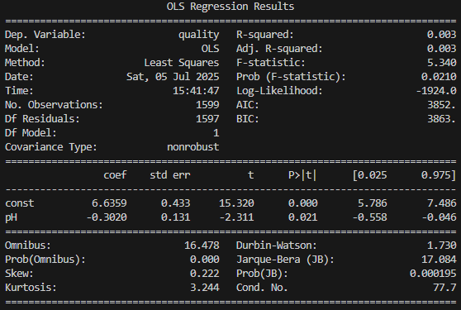
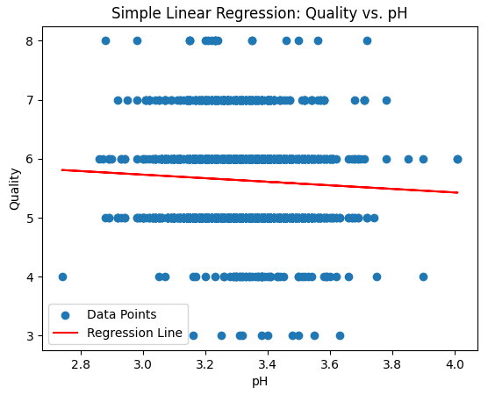

Activity 1 Part 3. Run a multiple regression to predict the variables that influence quality.
# Run a multiple linear regression with a target variable as 'quality' and all the other variables as the predictor variables. A summary of the output with model interpretation.

import pandas as pd
import statsmodels.api as sm

# df = pd.read_csv('/content/winequality.csv')

# Define the target variable (dependent variable)
target_variable = 'quality'

# Define the predictor variables (independent variables)
predictor_variables = df.drop(columns=[target_variable]).columns

# Create the model
X = df[predictor_variables]
y = df[target_variable]

# Add a constant to the predictor variables (intercept term)
X = sm.add_constant(X)

# Fit the multiple linear regression model
model = sm.OLS(y, X).fit()

# Print the model summary
print(model.summary())

# Model Interpretation
print("\nModel Interpretation:")
print("R-squared:", model.rsquared)
print("Adjusted R-squared:", model.rsquared_adj)

print("\nCoefficients:")
for col, coef in zip(X.columns, model.params):
print(f"{col}: {coef}")

print("\nP-values:")
for col, p_value in zip(X.columns, model.pvalues):
print(f"{col}: {p_value}")

print("\nInterpretation of Coefficients:")

# Example interpretation (you need to adapt this based on your specific variables)
# Iterate through the coefficients and their corresponding features.
for i in range(len(model.params)):
if i==0:
print(f"The intercept is {model.params[i]}.")
continue

feature = X.columns[i]
coefficient = model.params[i]
p_value = model.pvalues[i]

print(f"A one unit increase in '{feature}' is associated with a {coefficient:.2f} change in 'quality'.")
if p_value < 0.05:
print("This relationship is statistically significant (p < 0.05).")
else:
print("This relationship is not statistically significant (p >= 0.05).")
print("-" * 20)

print("\nOverall Model Assessment:")

# Assess the overall model fit based on R-squared, adjusted R-squared, and p-values.
print("The R-squared and Adjusted R-squared values suggest the goodness of fit. Higher values indicate that the model explains a greater proportion of the variance in the target variable.")
print("Examine the p-values for each predictor. P-values less than your significance level (e.g., 0.05) imply that the corresponding predictor is statistically significant.")

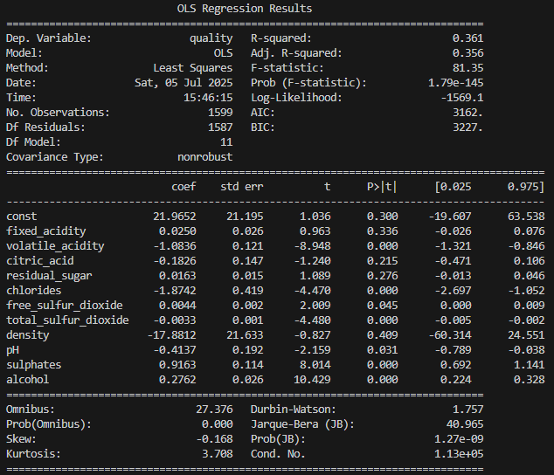
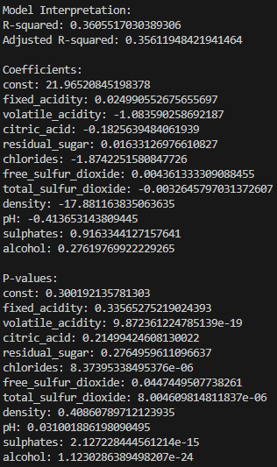

Activity 2. FOR PRACTICE Run a random forest regression (Unpruned).
# Gradient Boosting Regression with a target variable as 'quality' and all the other variables as the predictor variables. A summary of the output with model interpretation and a tree

import pandas as pd
from sklearn.ensemble import GradientBoostingRegressor
from sklearn.model_selection import train_test_split
from sklearn.metrics import mean_squared_error, r2_score

# df = pd.read_csv('/content/winequality.csv')

# Define features (X) and target (y)
X = df.drop('quality', axis=1)
y = df['quality']

# Initialize and fit the Gradient Boosting Regressor
gbr = GradientBoostingRegressor() # Use default parameters for now
gbr.fit(X, y)

#Feature Importance
feature_importance = gbr.feature_importances_
feature_names = X.columns
for i, importance in enumerate(feature_importance):
print(f"Feature: {feature_names[i]}, Importance: {importance:.4f}")

# Model Interpretation Summary (based on feature importance)
print("\nModel Interpretation:")
print("The Gradient Boosting Regressor identifies the following as the most important features for predicting wine quality:")
# Print the top 3 most important features
sorted_feature_importance_indices = feature_importance.argsort()[::-1]
for i in sorted_feature_importance_indices[:3]:
print(f"- {feature_names[i]} (Importance: {feature_importance[i]:.4f})")
print("Other features also contribute, but to a lesser extent.")

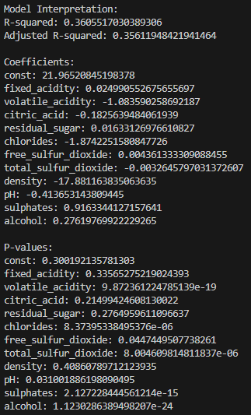

Activity 3. FOR PRACTICE PART 2 Run a gradient boost regression.
# Gradient Boosting Regression with a target variable as 'quality' and all the other variables as the predictor variables. A summary of the output with model interpretation.

import pandas as pd
from sklearn.ensemble import GradientBoostingRegressor
from sklearn.model_selection import train_test_split
from sklearn.metrics import mean_squared_error, r2_score

# df = pd.read_csv('/content/winequality.csv')

# Define features (X) and target (y)
X = df.drop('quality', axis=1)
y = df['quality']

# Initialize and fit the Gradient Boosting Regressor
gbr = GradientBoostingRegressor() # Use default parameters for now
gbr.fit(X, y)

#Feature Importance
feature_importance = gbr.feature_importances_
feature_names = X.columns
for i, importance in enumerate(feature_importance):
print(f"Feature: {feature_names[i]}, Importance: {importance:.4f}")

# Model Interpretation Summary (based on feature importance)
print("\nModel Interpretation:")
print("The Gradient Boosting Regressor identifies the following as the most important features for predicting wine quality:")
# Print the top 3 most important features
sorted_feature_importance_indices = feature_importance.argsort()[::-1]
for i in sorted_feature_importance_indices[:3]:
print(f"- {feature_names[i]} (Importance: {feature_importance[i]:.4f})")
print("Other features also contribute, but to a lesser extent.")

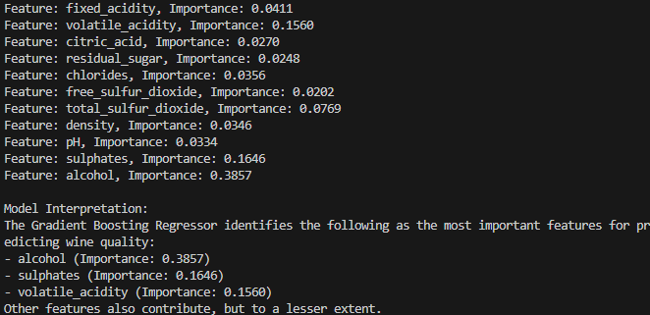

Activity 4. In a minimum of 3 sentences, describe your experience with the assignment. Indicate which resources you used.

Due to the new usage of imports, such as sklearn and statsmodel, I had to install them through bash commands. At the same time, due to my desire to document the code in separate folders, I had some trouble running the code in my terminal. Turns out I only needed to run the code when the current directory is inside of the folder to run the code correctly.

